

*MYKIDSBANKING.COM*

*Business Requirement & Software Development Proposal*

**Prepared by:** Romeo Rahman

**Prepared for:** Shirak Avakian.

**Product Inventor & Owner:** Shirak Avakian

**Company:** Technology Tray, LLC.

**Document Number:** 00001

**Security Classification: High**

**Version: 1**.0, 2.0

**Creation Date:** April 29, 2019

# Table of Contents

Table of Contents 2

1. Introduction 3

1.1. Purpose 3

1.2. Audience 3

1.3. What is Mykidsbanking.com? 3

1.4. How does Mykidsbanking.com work? 3

1.5. Business Objectives 4

2. Business Requirements 5

3. Functional Requirements 10

3.1. User Profiles Specification 17

3.2. Essential Use Case Specifications 18

3.3. Mykidsbanking.com workflow 18

3.4. Business Rules 19

4. Data Requirements 19

4.1. Data Architecture 19

4.2. Entity Relationship Diagram 20

4.3. Privacy Implications 20

5. Security Requirements 20

5.1. Admin 20

5.2. Authorization and Access Controls 21

5.3. Scalability Requirements 22

5.4. User Scalability 22

5.5. Application Scalability 22

6. Interface Requirements 22

6.1. User Interface Requirements 22

6.2. System Interface Requirements 23

7. Business Glossary 23

7. Revision Log 24

8. Appendices 24

# Introduction

## Purpose

Traditional toy buying trend declines as our children grow up. Nowadays, often invited guests ask the parents who are hosting their children’ birthdays or special events what would they prefer as a gift. Cash appears to be the most popular item so that the parents can collect that money and save it towards their college fund. In reality, most of the time that collected cash is saved in a safe deposit box at home and sometimes parents tend to use that money for a quick urgency and return it later. Therefore, the idea surfaced to create virtual safe deposit box for the children to save money from parents and children not having the immediate access to the fund.

The purpose of this document is to describe the business workflow, functional requirements and design of Mykidsbanking.com application and serve as a guide for the application development effort estimation and implementation process.

## Audience

The intended audience for this document is:

* Mykidsbanking.com Owner, stake holders
* Development Team
* Investors

## What is Mykidsbanking.com?

Mykidsbanking.com is a web application that accommodates families with virtual banking services where parents, guardians to create an account for their children and able to name or label the accounts whatever they wish to call it. It is a virtual account. The virtual account will be interlinked with the actual bank account that is established under the Technology Tray LLC account (Service Provider). The deposit will be made through the virtual account but the currency will be saved in the Technology Tray LLC account. The saved money is always available for the account holders to be withdrawn.

Mykidsbanking is a hybrid application which will run on the web, all mobile phones (iOS, Android) and tablets.

## How does Mykidsbanking.com work?

Parents, Guardians will require to signup with mykidsbanking.com, add their children’ information, create account for each child and name or label as they desire. Once the account is created, they will be able to view the profile link and barcode on the screen. Both profile link and barcode will be shared directly to the public facing external users who requests for the fund recipient child’s profile so that they can contribute fund to the recipient child’s associated account.

External users (i.e. fund contributors) will be able to read the shared participating child’s profile message (i.e. “college fund”, “Learn abroad program” etc.) the intended purpose for the fund requested by the participating child. The contributor will be able to pay his or her desired gift amount online directly the child’s account via the shared profile link or barcode. The contribution amount will be deposited/saved into the child’s account. Participating child’s parents will be able to withdraw fund at anytime. There will be no grace period or penalty for early withdrawal of fund. Parents will have access to the total amount (-) service charge of the saved fund.

*Mention here briefly if these business requirements are as a result of any previous meetings, correspondence, legislations etc*.

## Business Objectives

1. A web application with the following menus: Home, Services, Pricing, Testimonials, Contact us, About us, and FAQ.
   1. Home page: Logo (global place holder), Header, Sign up, Sign up with social media accounts, Sign In, Sign Out, Create a Fund information (how to content Display), Contribute to a Fund (how to content display), forgot or want to change password
   2. Dashboard (Dashboard focused to logged-in user): Home🡪Dashboard Navigation, Dashboard pager header, Dashboard display: Welcome message display with the logged-in user name (global place holder), Total number of Funds, Total number of funds on hold, Total number of invitations, Total number of Contributors, Total balance amount, Total Pending Amount, Fund Type drop-down menu, Fund Type content display, View/Manage button to drill down information, Fund Name or label, Create New Fund button.
   3. Dashboard-New fund page?
   4. Manage Fund page: Home🡪Dashboard🡪Manage Fund Navigation, Manage Fund detail form.
   5. Contribution page for the account holder.
   6. Contribution confirmation receipt.
   7. Profile log-in form: Login info, parent info, Children Info, Billing Info, Settings.
2. Membership plugin
3. Payments plugin
4. UI Design
5. Backend Design
6. Development
7. Site Content (To be provided by the application owner)
8. Domain name: mykidsbanking.com
9. Hosting
10. Webservices (Amazon Web Services)
11. Security
12. Native apps across all mobile devices
13. SEO

State the major benefits that the implementation of these Business Requirements will result in. Mention both tangible and intangible benefits expected.

Describe the dependencies between this Application (for which these Business Requirements are written) and other existing systems.List here all the external reference documentation, hyperlinks to web pages etc. that are directly related to these Business Requirements.

Describe major assumptions that were made (or exist) for these Business Requirements.

# Business Requirements

This section shows what business functionality is in the scope for Implementation.

Wireframes are provided in the Interface Requirements section below.

|  |  |
| --- | --- |
| **Number** | **Description** |
| **Home** | |
|  | Guest will be able to access the mykidsbanking.com to view and learn about the site services (i.e. Create a fund, Contribute to a fund) |
|  | Guest will be able to view the following information on the home page:   1. Site logo 2. Page header 3. Create a fund 4. Contribute to a fund 5. Sign in 6. Sign up |
|  | Parents will be able to Sign up on the mykidsbanking.com site |
|  | After parents completes their sign-up; their password will be encrypted. |
|  | Parents will be able to Sign up with their Twitter, Facebook or Google+ account |
|  | Parents will be able to Sign In to the mykidsbnking.com with their login and password credential |
|  | Non-member will not be able to log into the site |
|  |  |
| **Profile** | |
|  | Parents will be able to create a profile |
|  | Parents will be able to create multiple profiles for both parents |
|  | Parents will be able to create their child’s profile |
|  | Parents will be able to create multiple profiles for their children |
|  | Parents will be able to create an account(s) and associate the account under a child’s name or children’s names |
|  | Parents will be able to give limited access (read only) to their children |
|  | Parents will able to manage billing activities online |
|  | Parents will be able to create a joint fund for multiple children (i.e. for twins or triplets or siblings) |
|  | After the contributor receives an invitation from the host; as the contributor accesses the invitation link or QR barcode, contributor will be prompted to select the relationship between the contributor and the host (i.e. Family, Relative or Friend etc.) on the contribution payment form. |
|  | When the contributor accesses the invitation link or QR barcode, contributor will be able to see a join me option on the invitation ticket. If the contributor decides to join; the contributor will be prompted on his or her profile creation form to select the relationship between the contributor and the host/person who invited the contributor (i.e. Family, Relative or Friend etc.). |
|  | Parents will be able to associate a fund to a connection hub/RSVP to a 3rd party company (i.e. Amazon, Target etc.). So that parents can streamline the fund amount that reaches its goal amount to be disbursed for a specific item (i.e. PS4) that the child wanted to buy. |
|  |  |
| **Dashboard** | |
|  | Member will be able to sign in with his or her username and password and land on his or her Dashboard |
|  | Upon sign into the site; member will be able to view the following information on the dashboard:   1. Site logo 2. Page header 3. Welcome message with the logged in member’s name 4. Total number of funds (i.e. 3) 5. Total number of funds on hold? (i.e. 3) 6. Total number of invitations (i.e. 3) 7. Total number of contributors (i.e. 3) 8. Total fund amount (i.e. $3780.00) 9. Total pending amount? (i.e. $100.00) 10. Fund type (drop down) 11. Fund name/label (field) 12. Fund detail     1. Fund name (i.e. College Fund)     2. Fund holder’s name (i.e. Jivan Avakian)     3. Account number (i.e. 123456789)     4. Fund amount (i.e. $1800.00)     5. As of date (i.e. 05/03/2019)     6. View/Mange (button) 13. Create New Fund (button) |
|  | Member will be able to view or manage the fund |
|  | Member will be able to create a New Fund |
|  | Authorized child will be able to log into his or her account to view fund information |
| **Dashboard New Fund** | |
|  | Same feature and functionality as the dashboard |
| **Manage Fund** | |
|  | Member will be able to access the manage fund page from Dashboard |
|  | Member will be able to view the following information on the manage fund page:   1. Site logo 2. Home🡪Dashboard🡪College fund (Jivan Avakian) [Navigation or Breadcrumb trail] 3. Welcome message with the logged in user’s name (Global message) 4. Fund detail form:    1. Fund Type (i.e. College Fund)    2. Account holder name (i.e. Jivan Avakian)    3. Fund Amount (i.e. $555.00)    4. Date (i.e. as of 05/03/2019)    5. Account number (i.e. 2001222100)    6. Date Created (i.e. 11/01/2018)    7. Search    8. Print Summary    9. Statements    10. Deposit activity grid with pagination (i.e. 1>2>3)        1. Date (column)        2. Activity (column)        3. From (column)        4. Amount (column)    11. Contribution link    12. Message to Contributors    13. Save button    14. Withdraw (button)    15. Close the Fund (button)    16. Fund Type (drop down) (Optional selection, type ahead field)    17. Fund nickname (field)    18. Description (field)    19. Max contribution amount (currency field)    20. Target amount (currency field)    21. Notify on contribution (check box- notification is triggered upon selecting the option)    22. Save (button) |
|  | Member will be able perform search fund information |
|  | Member will be able to print fund summary |
|  | Member will be able to view fund statement |
|  | Member will be able to withdraw from fund |
|  | Member will be able to Close the fund |
|  | Member will be able to populate the following fields: Fund type, fund nickname, description, max contribution amount and Target amount and save it. |
|  | Parent will be to able to choose different money transfer option (i.e. Wire Transfer) from mykidsbanking to their own account but they will be charged by mykidsbanking service provider with amount what bank charges (i.e. $25.00 per money wiring transaction). |
| **Contribution detail** | |
|  | Contributors will be able to send the contribution via contribution link |
|  | Contributors will be able to access contribution payment form upon clicking on the contribution link which will be sent by the host. |
|  | Contributors will be able to view the following information on contribution detail page:   1. Site logo (global) 2. Account holder name (i.e. Jivan Avakian) 3. Fund label (i.e. My College Fund) 4. Account number (i.e. 2001222100) 5. Date Created (i.e. 10/29/2018) 6. Picture of the account holder and name 7. Account holder’s message about the fund 8. Payment detail:    1. Full Name (field)    2. Email (field)    3. Payment Method (i.e. Credit Card, E-Check, PayPal etc.)    4. Name on Card (field)    5. Card Number (field)    6. MM/YY (field)    7. Code (field) 9. Billing Address:    1. Address (field)    2. Address 2 (field)    3. City (field)    4. State (field)    5. Zip Code (field)    6. Text (field)    7. Send Contribution (button) |
|  | Contributors will be able to enter payment information and send the contribution to the fund holder |
| **Contribution Confirmation/Receipt** | |
|  | Contribution Confirmation will have the following information:   1. Site logo (global) 2. Fund label (i.e. My College Fund) 3. Account Number (i.e. 5446565568) 4. Welcome message along with the current user’s name 5. Fund holder’s picture and name 6. Fund holder’s message about fund raising goal 7. Pre-scripted thank you note to the contributor from the fund holder 8. Transaction ID (i.e. 12345799) 9. Amount (i.e. $500.00) 10. Date (i.e. 04/29/2019) 11. System generated promotional coupon and invitation note for the contributors to join the site |
|  | Contributors will be able to receive an instant confirmation upon sending the contribution to the fund holder |
|  | Contributors will have the option to join the mykidsbanking.com site from the contribution confirmation receipt |
| **Profile Login** | |
|  | Profile Login will have the following information:   1. Site logo (global) 2. Site Navigation or breadcrumb trail (i.e. Home🡪Profile🡪Login Info 3. Global Welcome message with the logged in user’s name (i.e. Shirak Avakian) 4. Left menu panel:    1. Login Info    2. Parent Info    3. Kids Info    4. Billing Info    5. Settings 5. Login Info form:    1. Email address (field)    2. Password reset (fields)    3. Request for password reset (button)    4. Login Activity grid:       1. Check box (Column)       2. Activity (column)       3. Date (column)       4. Time (column) |
|  | User will be able to reset password |
|  | User will be able to view the login activity log |
|  | User will be able to view parent’s information accessing the parent info menu |
|  | User will be able to view billing information accessing billing info menu |
|  | User will be able to perform system settings tasks accessing settings menu |

# Functional Requirements

This section describes the *Functional requirements* for mykidsbanking.com web application

|  |  |
| --- | --- |
| **Home** | |
|  | Create the mykidsbanking.com homepage with the following tabs:(please see the homepage wireframe below)   1. Home 2. Services 3. Pricing 4. Testimonials 5. Contact us 6. About us 7. FAQ   (Homepage content and aesthetics to be provided by the product owner) |
|  | User will type in the URL mykidsbanking.com into the address field to access the site |
|  | Create intro slide (images to be provided by the product owner) |
|  | Ability to sign-in with Social Media sign-in credentials |
|  | Ability to sign-up with username and password |
|  | Upon creating the password; it would be delivered and displayed as encrypted |
|  | Google authenticator will be integrated to secure the user account (i.e. credentials) |
|  | Ability to change password if the user forgets the password |
|  |  |
| **Dashboard** | |
|  | Create a Dashboard page view (Please see the wireframe below in the document)   1. Global site logo 2. Dashboard label/title 3. Welcome message to the current logged in user 4. Quick overview of the account/fund under the same logged in user    1. Total number of funds    2. Total number on holds    3. Total number invitations    4. Total number of contributors    5. Total fund amount    6. Total pending fund amount 5. Individual account/fund view   (More detailed necessary fields and features to be provided by the product owner) |
|  | Upon logging in; user will be directed to the Dashboard |
|  | Create a navigation breadcrumb from Home page to Dashboard and reverse |
|  | Create a parent’s profile   1. Upon logging into the site 2. User will be directed to the Dashboard 3. User will be guided step-by-step through wizard |
|  | Create a parent’s profile form (form content and necessary fields to be provided by the product owner) |
|  | Ability to add multiple parents on a parent’s profile |
|  | Add required fields in the parent’s profile form to add multiple parents |
|  | Create a child’s profile   1. Upon logging into the site 2. User will be directed to the Dashboard |
|  | Create a child profile form (form content and necessary fields to be provided by the product owner)   1. Child’s Name 2. Child’s birthdate 3. Profile Creation Date 4. Child’s profile picture 5. Child’s fund message (about the fund purpose) |
|  | Ability for parent user to create username and password for the account/fund holder child with read only access |
|  | Create a child’s account/Fund   1. Upon logging into the site 2. User (parent) will be directed to the Dashboard 3. User (parent) will select a fund type from the “Fund Type” drop down menu 4. User (parent) will enter a fund nick name in the “Fund Nick Name” field 5. User (parent) will click on the “Create New Fund” button 6. Fund will be created |
|  | Create a child’s account/fund form (form content and necessary fields to be provided by the product owner)   1. Child’s account number field 2. Fund type drop down menu 3. Fund Nick Name field 4. Fund amount balance field 5. Pending fund amount field (Parent can go in and set the pending amount) 6. Fund balance as of date |
|  | Display an Account/Fund snapshot   1. Account/Fund name 2. Account/Fund holder’s name 3. Account# 4. Fund Balance 5. Fund Balance as of date 6. Pending amount 7. View/Manage button |
|  | Ability to add multiple children into one account/fund   1. Upon logging into the site 2. User will be directed to the Dashboard 3. User (parent) will create a child’s account 4. User (parent) will add another child in the account |
|  | Ability for user (parent) to assign read only access to a child to view his or her account information   1. Upon logging into the site 2. User (parent) will be directed to the Dashboard 3. User (parent) will go to the account 4. User (parent) will assign read only access to a child or multiple children |
|  | Ability to edit an account/fund   1. Upon logging into the site 2. User (parent) will be directed to the Dashboard 3. User (parent) will click on the View/Manage button 4. Fund will open into fund edit form   (More detailed necessary fields and features for the Fund edit form to be provided by the product owner) |
|  | Ability to disable an account/fund |
|  | Create a payment form to make contribution (please see the wireframe attached below)   1. Fund name 2. Account number 3. Child’s Name (Fund holder) 4. Child’s profile picture display 5. Message about the fund 6. Invitee/Contributor’s full name 7. Invitee/Contributor’s email 8. Payment method:    1. Credit Card    2. *e*-Check    3. PayPal    4. Google Pay    5. Apple Pay 9. Name on the Card 10. Card Number 11. Exp. Month 12. Exp. Year 13. Code 14. Billing Address:     1. Address 1     2. Address 2     3. City     4. State     5. Zip code     6. Comment     7. “Send Contribution” button |
|  | Create the interface between child’s fund and mykidsbanking custodian bank account so that after the contributions are made it can be directly deposited to the mykidsbanking custodian account to be managed. |
|  | Create an invitation   1. Upon logging into the site 2. User (parent) will be directed to the Dashboard 3. User (parent) will create a child’s profile 4. User (parent) will create a child’s account/fund 5. Invitee form will be displayed 6. User (parent) will populate the invitee form with invitee information on behalf of the child    1. Invitee name    2. Invitee email    3. Invitee phone number    4. Invitation message    5. (Necessary fields and features for the Invitee form to be provided by the product owner) 7. User (parent) will click on the “Send Invitation” button 8. Invitation will be sent to the selected invitees 9. Invitees will receive an invitation link along with a QR barcode to their email inbox 10. Invitee/Contributor will click on the invitation/contribution link and it will direct the invitee/contributor to the contribution payment 11. If the invitee/Contributor wishes to use the QR barcode instead via his or her mobile mykidsbanking app to perform the same function as the invitation link |
|  | Create an invitation/Contribution hyper link |
|  | Create a QR barcode upon creation of an invitation/contribution link for the mobile apps |
|  | Create connection hub or RSVP between 3rd party (i.e. Target) for the Invitees/Contributors |
|  | Ability for the account/fund holder child to log into the dashboard to view his or her account/fund information |
|  | Ability for the parent user to give refund to the invitee/contributor |
|  | Create a refund form (Necessary fields and features for the refund form to be provided by the product owner) |
| **Invitee/Contributor Function** | |
|  | Ability to make contribution   1. Upon receiving an invitation from the host parent on behalf of a child; invitee/contributor will click on the invitation/contribution link and it will direct the invitee/contributor to the contribution payment form 2. Invitee/Contributor will populate the payment form 3. Invitee/Contributor will click on the “Send Contribution” button 4. Transaction will be completed 5. Host will be notified via email and or mobile app notifier 6. Invitee/Contributor will receive a payment confirmation/receipt 7. Invitee/Contributor will also receive an invitation from the host to join mykidsbanking.com along with a promocode |
|  | Ability for the Invitee/Contributor to join mykidbanking.com |
|  | Ability for the Invitee/Contributor to request for a refund from the host |
|  | Ability for the Contributor’s choice of payment (i.e. Cash) step by step process from giving the cash to the parent and convert the cash into deposit, give receipt |
|  | Create a contribution receipt form (Please see the wireframe below)   1. Global site logo 2. Page title 3. Fund Name 4. Account Number 5. Account/Fund holder child’s profile picture (Global source) 6. About the Fund message 7. Thank you note for the contribution 8. Transaction ID 9. Contribution Amount 10. Date of Contribution 11. To Join mykidsbanking.com site invitation to the Invitee/Contributor (message) 12. Promo Code 13. Email field (Contributor) 14. Password field (Contributor) 15. Confirm password field (Contributor) 16. “Join Now it’s Free” button |
| **Manage Account/Fund** | |
|  | Ability for the parent user to view and manage the child’s account/fund   1. Upon logging into the mykidsbanking.com site 2. User (parent) will be directed to the Dashboard 3. User (parent) will click on the View/Mange button 4. Account/Fund detailed information will be displayed |
|  | Create View/Manage page (please see the wireframe below in the document)   1. Global logo 2. View/Manage page header/title 3. Welcome message to the logged in current user’s name display 4. Home🡪Dashboard🡪Name of Account/Fund holder (Child’s name) navigation breadcrumb 5. Fund name 6. Fund holder’s name 7. Fund balance amount 8. Current date of the fund balance 9. Account number 10. Date created (Account/Fund) 11. Search field 12. Search function button “Find” 13. Print Summary menu 14. Statement menu 15. Contribution Activity grid:     1. Contribution Date:     2. Activity     3. From     4. Amount 16. Contribution grid pagination (i.e. 10 records per page) 17. Page numbers of the grid 18. Withdrawal menu 19. Close the Fund menu 20. Fund Type drop down menu 21. Fund Nickname field 22. Description field 23. Max Contribution Amount 24. Target Amount 25. Contribution notifier check box 26. (Necessary fields and features for the page to be provided by the product owner) |
|  | Ability for the parent user to perform global search in the Account/Fund detail page   1. User will enter a name or amount or date in the search field 2. User will click on the Find button 3. The search will return the expected result |
|  | Ability for the parent user to print the child’s account/Fund detail   1. User will click on the “Print Summary” menu 2. It will print the account/fund summary |
|  | Create a Print view page (Print Summary page content view, fields, aesthetics to be provided by the product owner) |
|  | Ability for the parent user to view Statement on the child’s account/fund   1. User will click on the Statement menu 2. A pop-up screen will come up and account/fund statement will be displayed |
|  | Create Statement view page (Statement page content view, fields, aesthetics to be provided by the product owner) |
|  | Ability for the parent user to withdrawal fund   1. User will click on the Withdrawal menu 2. User will populate necessary fields in the Withdrawal form 3. Withdrawal amount will be dispatched to expected form (i.e. direct deposit, *e-*check, fund transfer, wire transfer etc.) 4. A receipt will be generated upon completion of the transaction |
|  | Create a Withdrawal form (Necessary contents, fields, aesthetics to be provided by the product owner) |
|  | Ability for the parent owner to Close the Fund   1. User will click on the Close the Fund menu 2. User will populate necessary fields in the Close the Fund form 3. Account/Fund will be closed. 4. A receipt will be generated upon completion of the transaction |
|  | Create a Close the Fund form (Necessary contents, fields, aesthetics to be provided by the product owner) |
| **Profile Log-in** | |
|  | Create a Profile page   1. Global site logo 2. Page header/Title 3. Logged in user’s name and welcome message 4. Home🡪Profile navigation breadcrumb 5. Left menu panel:    1. Login Info    2. Parent Info    3. Kids Info    4. Billing Info    5. Settings 6. Login Activity grid:    1. Check box number column    2. Activity column    3. Date column    4. Time column |
|  | Ability for the parent user to submit a password reset request   1. User will go to login Info menu 2. User will enter the email address 3. User will click on the “Request to Reset” button 4. User will receive an email notification as a hyperlink 5. User will confirm the notification by the clicking on the link 6. System will take user back to the mykidsbanking.com login page 7. User will enter and confirm a new password 8. (Necessary fields and contents to be provided by the product owner) |
|  | Ability for the Admin user to track and monitor login activity (Product owner to be determined under which menu the activity grid should remain and display) |
|  | **Activity grid** **should only be available for mykidsbanking.com system admin users**. |
|  | Create Login Info menu page/view (Necessary fields, sub menus, functionalities, contents and aesthetics to be provided by the product owner) |
|  | Create Parent Info menu page/view (Necessary fields, sub menus, functionalities, contents and aesthetics to be provided by the product owner) |
|  | Create Kids Info menu page/view (Necessary fields, sub menus, functionalities, contents and aesthetics to be provided by the product owner) |
|  | Create Billing Info menu page/view (Necessary fields, sub menus, functionalities, contents and aesthetics to be provided by the product owner) |
|  | Create Settings Info menu page/view (Necessary fields, sub menus, functionalities, contents and aesthetics to be provided by the product owner) |
|  | Generate auto notification when an account/fund holder child reaches 18 years of age to offer the option to have his or her own account |
| **Apps for Mobile Devices** | |
|  | Create apps. for all mobile devices   1. All functionalities above should be integrated into all mobile apps |

## User Profiles Specification

This section describes all the Users and their profiles within the context of the Business Requirements being documented. A user is a person, organization or an external system/sub-system/program that has interactions with the Application. Users, by definition, are external to the system with which they are having interactions. Users have goals that are achieved by use cases. Typically, Users have behaviour that are represented by the roles they act in the use cases. A User stimulates the system by providing input and/or receiving something of measurable value from the system.

|  |  |  |  |
| --- | --- | --- | --- |
| **User Name** | User Type | Access Type needed | Role |
| User1 | Stakeholder  Admin  Super user | Create  Print  Read  Export  Update  Others  Delete | Admin.  Super user.  Need all access. |
| User2 | Parent | Create  Print  Read  Export  Update  Others  Delete | CRU only their records.  View only member Menu. |
| User3 | Child (Member) | Create  Print  Read  Export  Update  Others  Delete | View only. |

If Function Hierarchy Diagram (FHD) modeling is done using Oracle Designer for these Business Requirements instead of Use case modeling, then please document the Actor Profile information under **“Business Units”** folder of the Designer and then generate and attach the **“Business Units Definition”** report from Oracle Designer. This report is available under **“Repository Reports | Enterprise Modeling”** sub folders of the Oracle Designer.

Please include here the Essential Use Case Diagram for the Business Requirements. You may also provide additional context description below the diagram, if required. The Standards and Guidelines for Essential Use Case Diagram modeling are available at the following link on the ADE web site :

**Internet: http://www.bced.gov.bc.ca/imb/downloads/essentialusecasestandards.pdf**

**Intranet:** [**http://gww.msd.gov.bc.ca/itmb/adestandards/downloads/essentialusecasestandards.pdf**](http://gww.msd.gov.bc.ca/itmb/adestandards/downloads/essentialusecasestandards.pdf)

## Essential Use Case Specifications

This section is applicable only to Use case approach. This section describes each Essential Use case in diagram. A use case typically has one basic course of action and one or more alternate courses of actions. The basic course of action is the main start-to-finish path that the use case will follow, where as the alternate courses represent the infrequently used paths and exceptions, error conditions etc. The complete business logic of a use case such as basic course of action, alternate course of action, pre-condition, post-condition etc. is not depicted in the Use case diagram. Rather they are documented in narrative style in use case specifications.

**Component: Profile**

**Use Case Id: #001**

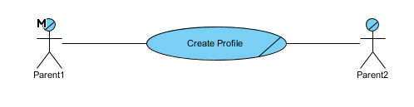

**Component: Profile**

**Use Case Id: #002**

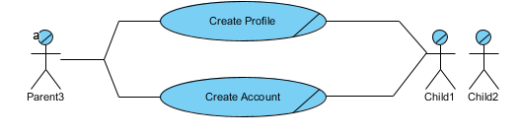

**Component: Manage Fund**

**Use Case Id: #003**

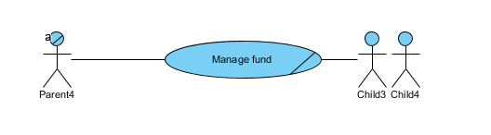

## Mykidsbanking.com Workflow Diagram

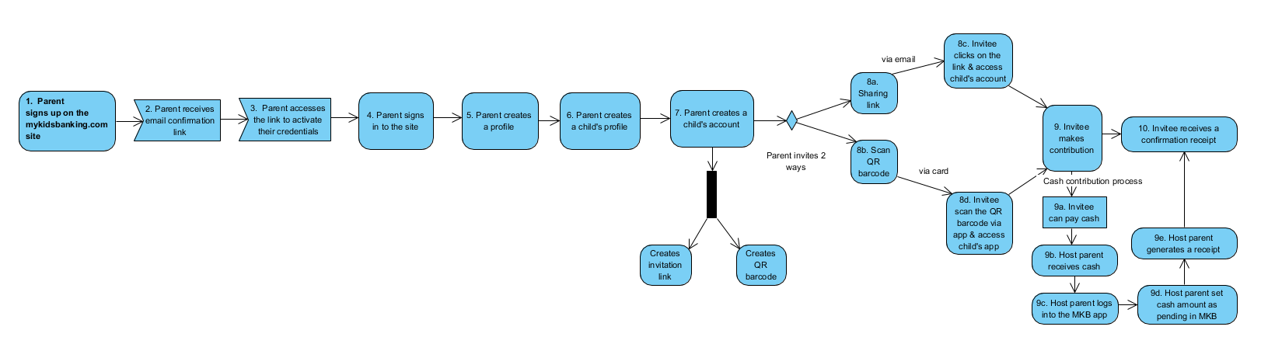

## Business Rules

This section lists and describes the business rules applicable to the proposed system.

|  |  |  |  |
| --- | --- | --- | --- |
| **Business Rule Id** | **Rule Name** | **Rule Description** | **Rule Source** |
| BR#001 | Sign in | All users need to have a valid username and password to access the application. | * + - Product Owner |
| BR#002 | Membership | All users need to signup for the mykidsbanking.com site to receive services. | * + - Product Owner |
| BR#003 | Guest User | Guest users do not need to signup to access the mykidsbanking.com site to learn about the services. | * + - Product Owner |
|  |  |  |  |
|  |  |  |  |
|  |  |  |  |
|  |  |  |  |
|  |  |  |  |
|  |  |  |  |

*If Function Hierarchy Diagram (FHD) modeling is done using Oracle Designer for the Business Requirements instead of Use case modeling, then please refer to “*[*Requirements Modeling and Specification Guidelines and Standards*](http://www.bced.gov.bc.ca/imb/downloads/reqmodstd.pdf)*” for standards and guidelines on modeling Business Rules in Designer.*

*Please refer to the following guidelines on business rule documentation :*

* *Document only Business rules here. Do not document workflow rules.*
* *There is no need to document rules (particularly structural rules) that are naturally expressed in the models and that are shown in the models.*
* *Document only semantic and explicit business rules or “unstructured” rules that do not appear in the models.*

# Data Requirements

This is a new system so we will have data as users start using the system and enter data into the system.

We will create some fictitious data during development period for system testing and demo purposes.

## Data Architecture

To be recommended by the application architect/owner.

***Notes***:

1. Any data that are entered by users directly into the Mykidsbanking.com system will be securely saved in the cloud.
2. Any attachments/images such as member’s picture that is uploaded will be securely saved cloud.

Please include here the Domain Class Diagram showing the following information :

* Class Name
* Attribute (field) Name
* Interrelationships between the classes (association, composition, aggregation and generalization)

The Standards and Guidelines for Domain Class Diagram modeling are available at the following link on the ADE web site :

**Internet: http://www.bced.gov.bc.ca/imb/downloads/classdiagramstandards.pdf**

**Intranet:** [**http://gww.msd.gov.bc.ca/itmb/adestandards/downloads/classdiagramstandards.pdf**](http://gww.msd.gov.bc.ca/itmb/adestandards/downloads/classdiagramstandards.pdf)

Alternately, even in Use case approach, you may provide Data models in ERD notation instead of Domain Class notation. In that case, delete section 4.1.1 (Domain Class Diagram) and proceed to next section (section 4.1.2).

## Entity Relationship Diagram

To be recommended by the DBA/Application Architect. If Entity Relationship Diagram (ERD) modeling is done using Oracle Designer for these Business Requirements instead of Domain Class modeling, then include here the conceptual ERD generated from Oracle Designer showing the following information :

* Entity Name
* Attribute (field) Name
* Interrelationships between the Entities (association, composition, aggregation and generalization)

The Standards and Guidelines for Entity Relationship Diagram (ERD) modeling are available at the following link on the ADE web site :

Internet: http://www.bced.gov.bc.ca/imb/downloads/reqmodstd.pdf

Intranet: <http://gww.msd.gov.bc.ca/itmb/adestandards/downloads/reqmodstd.pdf>

*Please describe the following high-level Data Conversion issues in this section :*

* *Data that is required to be converted (list of conceptual entities in the source database)*
* *High-level mapping between source and target “to be converted” conceptual data structures*
* *PIA/FOI and other compliance issues needed to be taken into consideration during data conversion*
* *Critical success factors*
* *Risks associated with the data conversion and contingency plans*
* *Data Conversion Acceptance criteria*

Please describe the time frames in number of years/months/days for online Data retention before the data is archived and purged.

Please describe if there are any other special data archiving requirements exist and the PIA/FOI and other compliance issues that need to be taken into consideration during data archival and for the archived data.

## Privacy Implications

This section describes the sensitivity levels of each class of data. The following criteria are used in determining the sensitivity level of each conceptual class/entity in line with the Government Core Policy Manual).

* **Protected A**: All data that are entered into the Mykidsbanking.com system and pass through the system will be protected with high caution using sophisticated security software to protect our members’ privacy.
* Technology to be recommended by the application owner.Please describe the FOI/Privacy Implications for each conceptual Class or Entity in terms of the criteria described above. Please use the following table. Add more rows as necessary.

For more information on Government FOI/Privacy policies and guidelines, please refer to the Core Policy Manual at the following link on the MSD web site :

[**http://www.cio.gov.bc.ca/prgs/core.htm**](http://www.cio.gov.bc.ca/prgs/core.htm)

# Security Requirements

This section describes the Security requirements part of the Business Requirements.

The security tool will be selected/recommended for the mykidsbanking application by the application owner/technology team.

For more information on Government FOI/Privacy policies and guidelines, please refer to the Core Policy Manual at the following link on the MSD web site :

[**http://www.cio.gov.bc.ca/prgs/core.htm**](http://www.cio.gov.bc.ca/prgs/core.htm)

## Admin

***References:***

**Data Accessibility**

* Entity profile information is publicly available via a searchable website
* Profile data is available for direct system-to-system access via an HTTP API (read only)
* System will track the date and time of last API data pull
* Profile details for individual institutions can be downloaded in Excel or PDF format

**Entity Profile Administration**

* Entities may submit online requests to have their profile added to the mykidsbanking.com
* Authorized users can update the entity’s profile directly on the website
* Date and user name are logged when profile is changed
* Designated entity representatives can delegate editing rights to other users at their institution

**User Accounts**

* User accounts are password protected (Utilization of InCommon Federation will be considered in future
* phases of development)
* Password reminders and resets are handled by the website
* With the exception of system administrators, all user accounts are tied to an institution

**Data Integrity**

* At designated intervals (at least monthly), the system sends an email reminding entity to update their profile
* System will also be able to send reminders on certain data elements when the data has become out of date
* If feasible, system will also provide alert/notification upon sign-in by entity user when any of the above dates
* or data elements requires updating
* Consideration will be given to requiring a Profile update at FDP Annual report time to help ensure Profiles
* are kept current
* New profiles must be reviewed and approved by FDP designee before appearing online

**System Security**

* Public has read-only access via website
* API provides read-only data access
* Profile editing requires password-protected user account with manually-assigned rights
* Change log records details on data modification (date, username)
* Consideration will be given to potentially hiding of email address from public view to avoid collection by spam senders

|  |  |
| --- | --- |
| **Admin** | |
|  | Create a user (i.e. parent) with CRU access |
|  | Create a user (i.e. child under 18) with R access only |
|  | Create a user (i.e. Admin) with CRUD access |
|  | Apply SSL certification to secure the site |
|  |  |

## Authorization and Access Controls

This section describes the Authorization and Access Control requirements part of the Business Requirements at a high-level. Authorization is the process of determining if the person/group, once identified through the “Authentication process”, is permitted to have access to certain services. The Authorization and Access Control requirements are best described through a matrix.

Please specify the Authorization and Access Control requirements between the various Actors/Business Units and the Domain Classes/Business Entities in the table below. Add more rows as necessary.

|  |  |  |
| --- | --- | --- |
| **User/ Business Unit Name** | **Business Entity Name** | **Type of Access Control needed on the Business Entity:**  **C 🡪 Create**  **R 🡪 Read**  **U 🡪 Update**  **D 🡪 Delete** |
| Product owner/Admin | mykidsbanking.com | CRUD |
| Parent User | As above | CRUD |
| Child User | As Above | R |
|  |  |  |
|  |  |  |

## Scalability Requirements

This section describes how the system is expected to scale to new higher or lower levels. Both user and application scalability requirements are described here.

## User Scalability

The mykidsbanking.com system will be designed and built in an efficient manner so that as the business grow the system should be able to handle higher volume of user traffic and transactions. Please describe how the user volumes are likely to grow in a given number of months or years. Example : 1000 new users are expected to use this internet system in the next 6 months.

## Application Scalability

The mykidsbanking.com system will be designed and built in an efficient way that all components will be upgradable which will allow to add more functionality, bandwidth and storage without major effort.

Please describe if any new major functionality/interface is likely to be added to the application in the next given number of months or years. Example : This system will have a new public facing (internet) interface in the next 1 year.

# Interface Requirements

This section describes User and System Interface requirements for the proposed system.

## User Interface Requirements

Please the attached wireframes below:

*The intended purpose of the wireframes is to provide a visual idea or guidance of the application features and or functionality not to be adapted for implementation.*

**mykidsbanking.com Home page**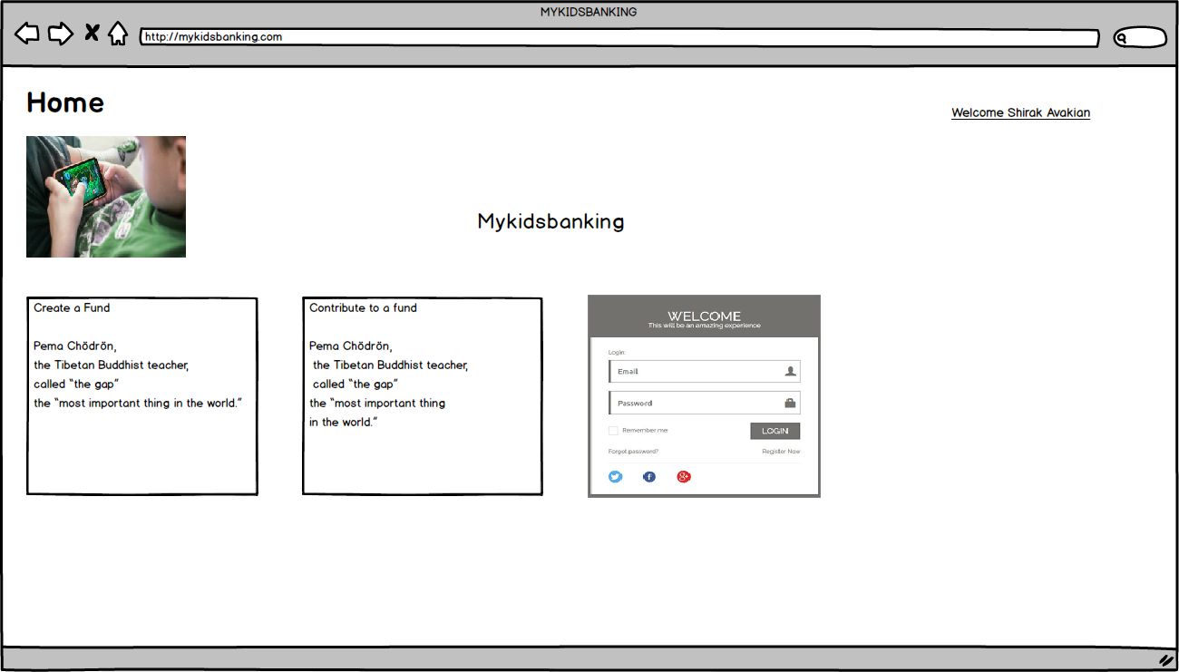Please describe here the user interface requirements. Include or attach a screen prototype diagram here.

**Dashboard**

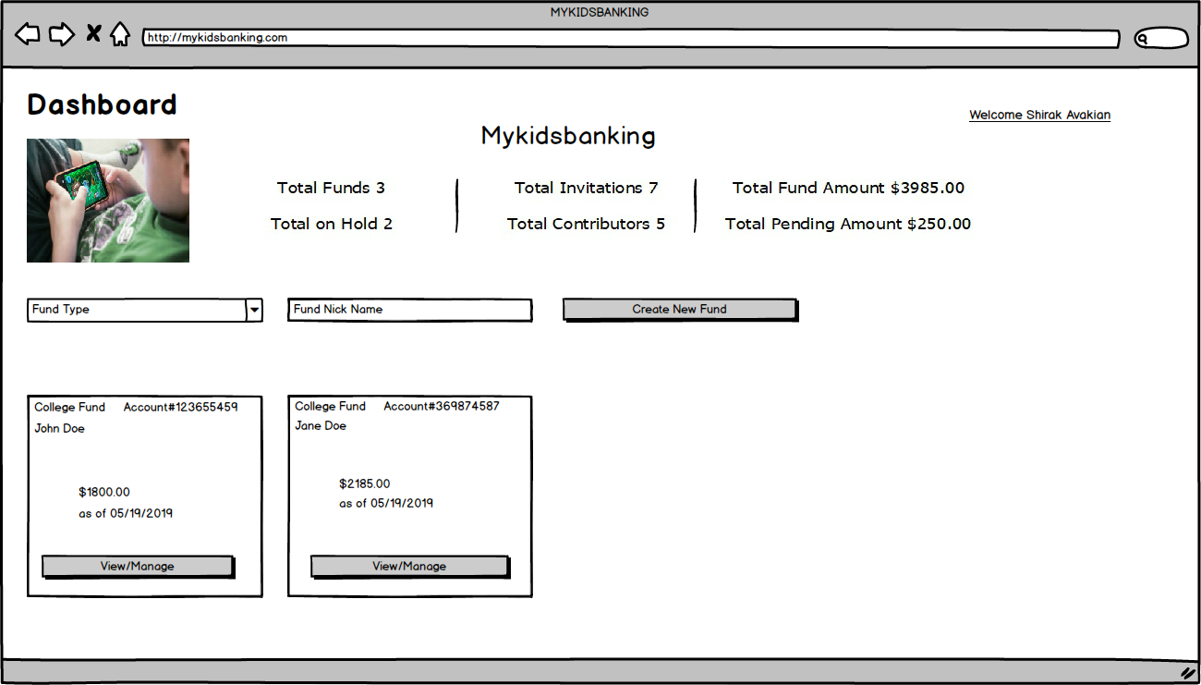

**Contribution Payment Form**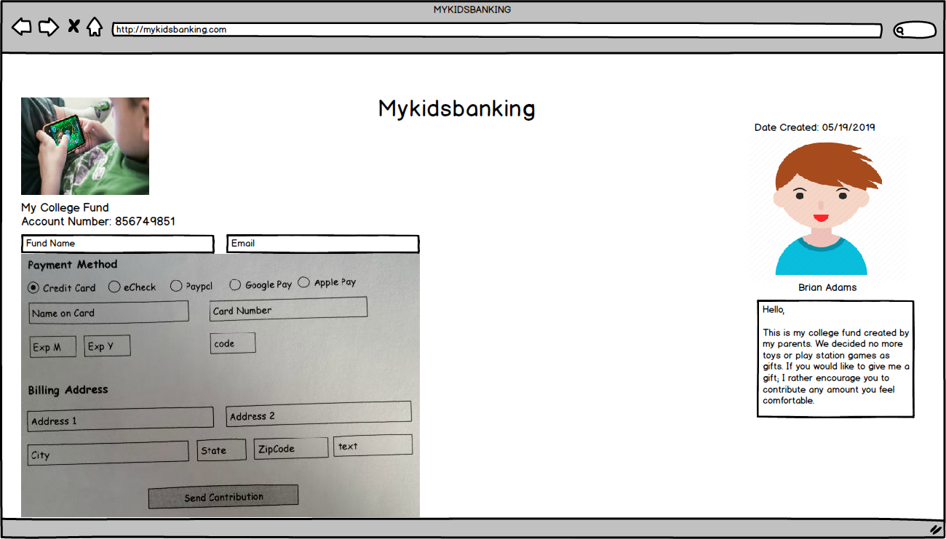

**Contribution Receipt**

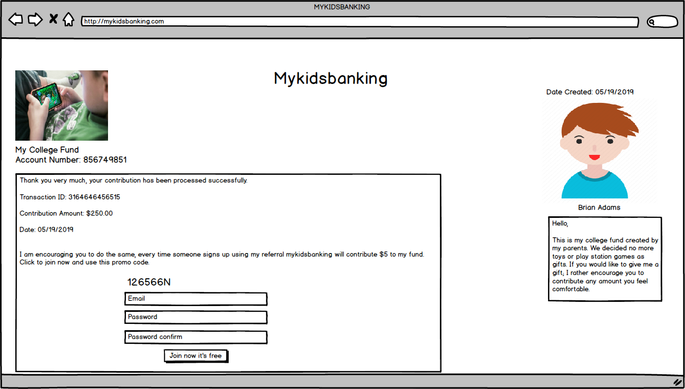

**Manage Fund**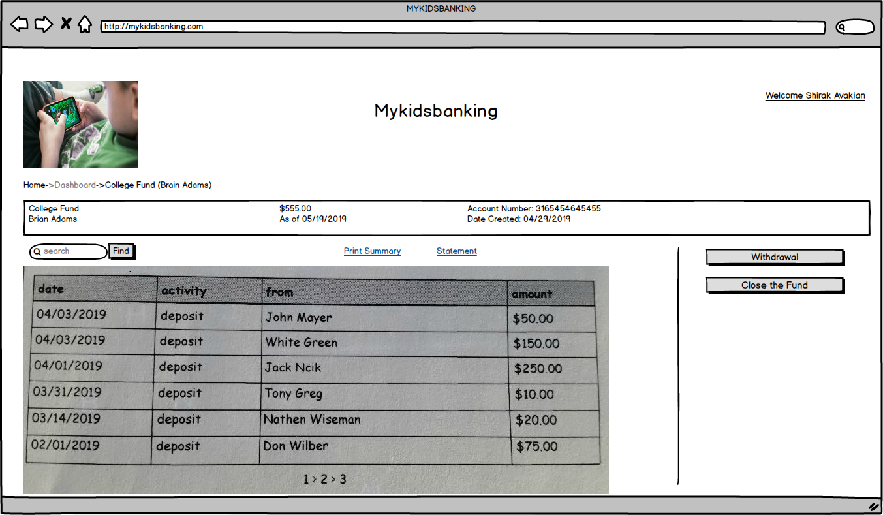

**Profile Login**

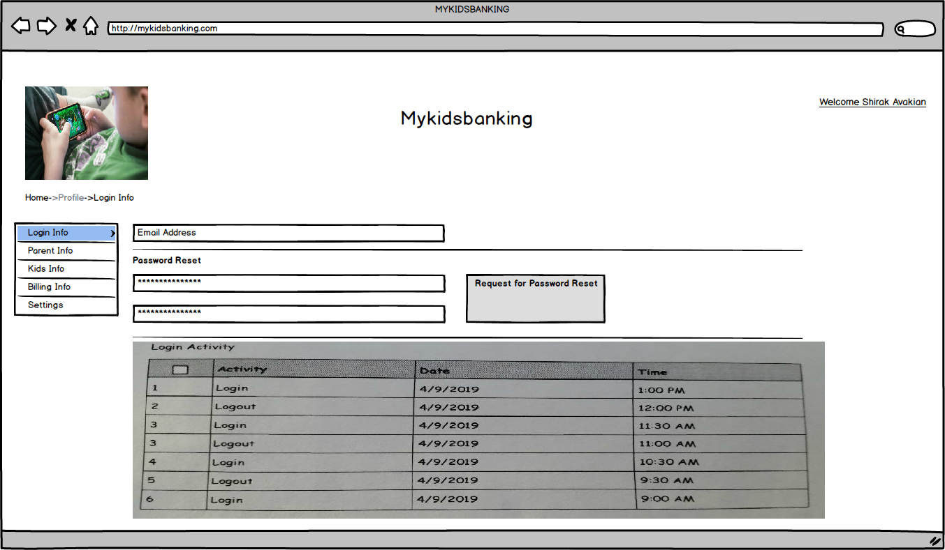

## System Interface Requirements

1. TBD (i.e. WordPress Membership Plugin.Please list and describe here what other external systems/business functions are required to be interfaced with the proposed system from Business Requirements perspective. Example : This system needs to interface with the CAS in order to receive some input data. Please avoid describing system design and technical issues.

)

# Business Glossary

|  |  |
| --- | --- |
|  |  |

|  |  |
| --- | --- |
| ***ITEM*** | ***Description*** |
| Application Name | mykidsbanking.com |
| Profile Creator | Parent |
| Member | Participating Child |
| Contributor1 | Guest Payer |
| Contributor2 | Parent Payer |
|  |  |
|  |  |
|  |  |

Please include here complete glossary of business terms used in this document.

# Revision Log

| Date | Version | Change Reference | Reviewed by |
| --- | --- | --- | --- |
|  |  |  |  |
| 05/01/2019 | 1.1 | Updated business requirements |  |
| 05/10/2019 | 2.0 | Added functional requirements |  |
| 05/17/2019 | 2.0 | Added the Admin section 5.1 |  |
| 05/18/2019 | 2.0 | Added wireframes |  |
| 05/19/2019 | 2.0 | Mykidsbanking.com workflow |  |
|  |  |  |  |
|  |  |  |  |

# Appendices

Each Appendix must have:

A separate header, numbered A-Z, with an appropriate descriptive title. Use the Heading 1 Style for each Appendix Header. This style will automatically insert a page break.

A lead in paragraph that states the importance of the data to this report

A closure, centred on a separate line, that repeats the header, such as End of Appendix A – Title.

N/A.